Visualization of scoliotic spine using  
ultrasound-accessible skeletal landmarks

Ben Church1, Andras Lasso1, Christopher Schlenger2,   
Daniel P. Borschneck3, Parvin Mousavi4, Gabor Fichtinger1,3, Tamas Ungi1,3

1. Laboratory for Percutaneous Surgery, School of Computing,  
    Queen’s University, Kingston, ON, Canada
2. Premier Chiropractic, Stockton, CA, USA
3. Department of Surgery, Queen’s University, Kingston, ON, Canada
4. Medical Informatics Laboratory, School of Computing,   
   Queen’s University, Kingston, ON, Canada

**ABSTRACT**

**PURPOSE:** Ultrasound imaging is an attractive alternative to X-ray for scoliosis diagnosis and monitoring due to its safety and inexpensiveness. The transverse processes as skeletal landmarks are accessible by means of ultrasound and are sufficient for quantifying scoliosis, but do not provide an intuitively comprehendible visualization of the spine. **METHODS:** We created a method for visualization of the scoliotic spine using a 3D transform field, resulting from thin-spline interpolation of a landmark-based registration between the transverse processes that we localized in both the patient’s ultrasound and an average healthy spine model. Additional anchor points were computationally generated to control the thin-spline interpolation, in order to gain a transform field that accurately represents the deformation of the patient’s spine. The transform field is applied to the average spine model, resulting in a 3D surface model depicting the patient’s spine. We applied ground truth CT from pediatric scoliosis patients in which we reconstructed the bone surface and localized the transverse processes. We warped the average spine model and analyzed the match between the patient’s bone surface and the warped spine. **RESULTS:** Visual inspection revealed accurate rendering of the scoliotic spine. Notable misalignments occurred mainly in the anterior-posterior direction, and at the first and last vertebrae, which is immaterial for scoliosis quantification. The average Hausdorff distance computed for 4 patients was 2.6 mm. **CONCLUSIONS:** We achieved qualitatively accurate and intuitive visualization to depict the 3D deformation of the patient’s spine when compared to ground truth CT.

**Keywords:** Spine, scoliosis, ultrasound, visualization

# INTRODUCTION

Scoliosis is a pathological, coronal curvature of the spine, typically greater than 10°. This quantification of the disease is in terms of the Cobb angle, the maximum angle between the endplates of any two vertebrae, illustrated in Figure 1. Scoliosis typically manifests during adolescence and develops with growth until skeletal maturity. If left untreated, this curvature can become sufficiently severe that back pain or respiratory problems develop. Once scoliosis is detected, continued monitoring and quantification is required to ensure that its progression is met with the appropriate treatment. Continued observation is required for Cobb angles less than 20°. Bracing can be used to slow the progression of the disease for Cobb angles between 20° and 40°. Any curvature in excess of 40° is often treated with surgical vertebral fusing.

X-ray imaging is still considered the gold standard for scoliosis quantification and visualization. The health risks associated with repetitive exposure to ionizing radiation during adolescence have motivated research [1], [2], and [3], into the use of spatially tracked ultrasound as an alternative imaging modality. Using spatially tracked ultrasound for scoliosis assessment generally consists of locating landmarks in 3D space and projecting them onto the coronal plane. A proxy to the Cobb angle is then extracted from the landmark data.

[2] approximated the Cobb angle by locating transverse processes from spatially tracked ultrasound snapshots taken in the parasagittal plane of phantom spine models. Operators captured snapshots once they believed they had a view of the transverse process, and the centers of the transverse processes manually located in the snapshots. By comparing the angle between the most tilted vertebrae from landmark locations to ground-truth Cobb angles measured from X-rays, [2] demonstrated that their transverse process method consistently produces accurate Cobb angles estimates. Figure 2 shows two views of the anatomic representation used in [2]’s method.

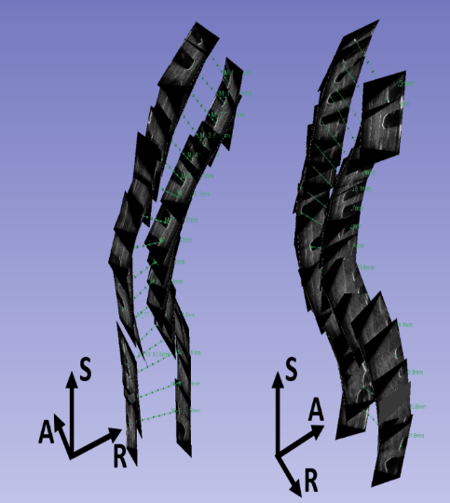

Figure 2: Two views of tracked ultrasound snapshots of transverse processes in virtual anatomic space as used by [Ungi2014].

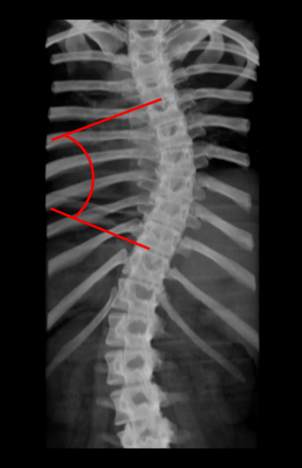

Figure 1: Digitally rendered radiograph from CT illustrating the Cobb angle.

[1] investigated two methods of quantifying scoliosis: Using the spinous profile, or using transverse process locations, from volume projection imaging. They use wide transducers in an axial orientation to scan the spine, enabling visualization of symmetric landmarks simultaneously. Operators scanned living patient’s spines with curvatures ranging from 1.9° to 29.9°, resulting in a series of ultrasound images along the axis of the spine. They project these images onto a curved surface lying along the sagittal curvature of the spine, and mapped this surface onto a 2D image. Operators then drew lines along inflection points of the profile of the spinous processes, and located the two most relatively tilted pairs of transverse processes. Operators were able to examine different depths into the images, to locate transverse processes where members of a pair are at various depths. By comparing the curvature extracted from the spinous process and transverse process locations to the Cobb angle measured from X-ray, they demonstrated the accuracy and repeatability of both methods.

[3] projected the series of ultrasound images resulting from a wide-transducer, axially oriented scan of the spine onto the anatomic planes. The laminae of each vertebra were located in the coronal image, and the midpoints between them located, manually. Lines connecting the centers of laminae were automatically drawn, from which the operator selects the two most relatively tilted lines. The angles produced by this method were compared to the patient’s Cobb angles measured from MRI. Their results suggest the potential utility of their ultrasound method for scoliosis quantification for its accuracy and repeatability.

Despite these methods’ utility in quantifying the severity of scoliosis, they do not provide clinicians or patients with a comprehensible visualization of the spine. The virtual environment in which participant’s located the transverse processes for [2]’s method (Figure 2), gives some impression of the patient’s 3D shape, but is difficult to relate intuitively to real anatomy. The visualizations used for [1] and [3]’s methods are 2D images derived from projecting ultrasound series onto a surface. As such, they do not convey an impression of the 3D shape of the spine.

[4] and [5] developed methods to model spinal anatomy for percutaneous spinal procedures by registering tracked ultrasound images to preoperative CT scans. Although both generally produce successful registration-based models, both methods require a CT scan. As such, they cannot be used if radiation exposure is to be minimized for scoliosis assessment. Motivated to develop a method not requiring ionizing radiation, [6] investigated using local phase tensor information to automatically segment vertebral bone surfaces from ultrasound images. Their method improves the results of subsequent 3D ultrasound to statistical model registration when compared to existing phase-based methods which use Log-Gabor or monogenic filters for segmentations. However, we have not found an open-source implementation of these methods, which would be important for evaluation of their success rate and reliability by other research groups.

In this paper, we propose a method for producing intuitively comprehensible visualizations of spinal anatomy. These intuitive visualizations could be used to aid clinicians and patients in comprehending their scoliosis not in terms of a single Cobb angle, or a set of landmarks, but in terms of its overall geometry. The surface model produced by our method could also be used as an initialization for a more detailed, image sequence based registration for interventional navigation. The proposed method uses transverse process locations as input, which can be located using tracked ultrasound, and therefore requires no ionizing radiation. Additionally, whereas previous methods may fail subject to ultrasound image quality, our method does not depend directly on ultrasound quality, and is therefore robust by simplicity. The visualization is produced by registering the patient’s transverse process points, supplemented with anchor points to constrain the registration’s deformation field, to corresponding points in an atlas model. This method is relatively simple, the majority of user interaction being required to locate the transverse processes; no parameter tuning is required.

# METHODS

To produce a deformation field corresponding to the difference between the average spine model (shown in Figure 3) and the patient’s anatomy, landmark-based registration was used. Landmark points were placed on the transverse processes of the average model, and four scoliotic patients’ models. The patient models were derived from previous CT scans and serve as ground-truths against which to compare the visualization produced for each patient. The sparsity and peculiar distribution of the points make it non-trivial to warp an average spine model to the patient’s skeletal landmarks in an anatomically accurate fashion. In each point set, the transverse processes align along two nearly parallel curves. Without constraint in the anterior-posterior direction, the deformation field cannot effectively describe scale in that direction. Vertebral rotation and global 3D curvature information must be present in the deformation field generated by the registration algorithm. We propose to address these issues by computationally adding matching anchor points in both registration point sets, in a manner that preserves the deformation field.

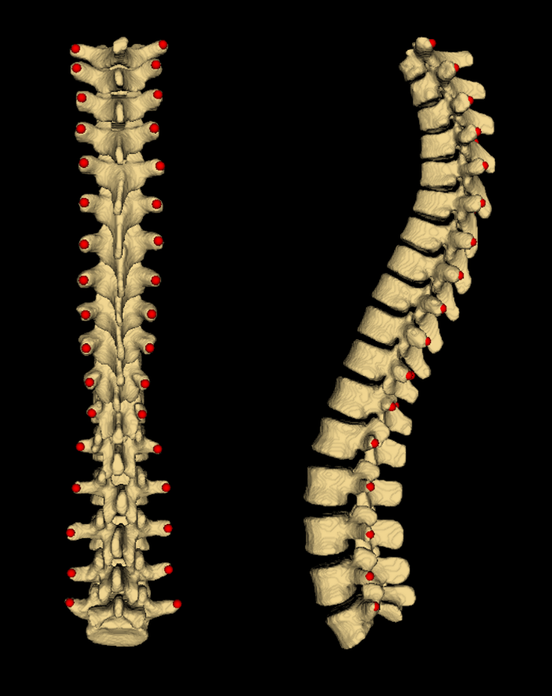

Figure 3: Undeformed average spine model with landmark points used for registration.

The anchor points are added at offsets normal to the curvature of the spines, in the anterior direction. To compute this normal direction consistently, vector cross products of right-left, and superior-inferior vectors are used to compute an anterior-posterior vector. This method defines piece-wise volumes, rather than the original curves. Since each piece of the volume corresponds to one vertebra, the registration algorithm imposes most of the deformation   
inter-vertebrally, rather than continuously along the curves. We account for the scale in length between the average spine and the patient’s spine by scaling the magnitude of the offset distance by the ratio of the length of the patient’s spine to the length of the average spine. To add the anchor point anterior to point P(i,j), where i denotes the vertebra (the superior-most being at i = 0), and where j denotes right versus left (j = 0 for left, j = 1 for right), the right-left vector was computed as:

$〈RL(i,j)〉=〈P(i,j)〉-〈P(i,j+1 \left(mod 2\right))〉$ (1)

where angled brackets denote vectors. Superior-inferior vectors are computed as the average of two possible vectors:

$〈SI\left(i,j\right)〉=\left[\left[〈P\left(i+1,j\right)〉-〈P\left(i,j\right)〉\right]+\left[〈P\left(i,j\right)〉-〈P\left(i-1,j\right)〉\right]\right]÷2$ (2)

At the superior and inferior extremities of the spine, where only one vertebra existed below or above the one to which an anchor point is being added, only the existing vector is used in equation (2). Finally, to determine the location of the anchor point, the anterior-posterior vector is computed as the cross product of the vectors from equations (1) and (2), normalized by dividing it by its length, and scaled by a vertebral scaling factor times the ratio of the length of the patient’s spine to that of the average spine:

$$〈P^{*}\left(i,j\right)〉=〈P\left(i,j\right)〉+〈AP\left(i,j\right)〉=〈P\left(i,j\right)〉$$ $+\left[VSF\left(i,j\right)∙ASF\left(i,j\right)\right]∙\left[〈RL\left(i,j\right)〉×〈SI\left(i,j\right)〉\right]÷\left|〈RL\left(i,j\right)〉×〈SI\left(i,j\right)〉\right|$ (3)

where the * denotes an anchor point being added, VSF is a vertebral scaling factor used to relate the size of the current vertebra’s local anatomy to the corresponding anatomy of the model, • denotes scalar multiplication, ASF is an anatomic scaling factor which conveys the overall scale of the inter-landmark spacing in the anchor point offsets, × denotes a vector cross product, and |V| denotes the length of vector V.

The VSF for vertebra i on side j is computed as:

$VSF\left(i,j\right)=\left(\left|〈SI(i,j)〉\right|÷\left|〈SI{\left(i,j\right)}_{model}〉 \right|\right)$ (4)

where the *model* subscript denotes that the superior-inferior vector is associated with the corresponding vertebra on the healthy model. Therefore, the VSFs for the healthy models are unity. This ratio factor reflects the length of the current spine anatomy, relative to that of the model. This causes a scaling of the spine model when it is deformed to the patient’s anatomy. The ASF is calculated as:

$ASF\left(i,j\right)=\left(\sum_{i=0}^{n-1}{\left(\left|〈SI\left(i,0\right)〉\right|+\left|〈SI\left(i,1\right)〉\right| \right)}\right)÷2(n-1)$ (5)

Where n is the number of vertebrae. That is, the ASF for each landmarks’ anchor points’ offset is the average of all of that spine’s landmarks’ superior-inferior vector lengths. The ASF magnitudes were constructed using the   
superior-inferior vector lengths so differences in anatomic scales might be reflected by similarly proportioned changes in the ASF. An average was used to prevent patient anatomy with alternatively longer and shorter vertebrae than the model from dilating and contracting the model in the anterior-posterior direction through any particular lengths of the spine.

Figure 4 shows a piece of the average spine model with the transverse process points, the anchor points, and the vectors locating an anchor point. The registration is as a thin-plate spline transformation between the two sets of points [7], as implemented in the Visualization Toolkit ([www.vtk.org](http://www.vtk.org)). The thin-plate spline transformation maps each transverse process and anchor point of the average spine to its corresponding point in the patient’s spine with a smooth interpolation. This yields a continuous 3D transform field that we apply to the average spine model, thereby warping it to match the patient’s spine.

To validate this method, we apply ground truth CT data sets from pediatric scoliosis patients. We reconstructed their spine surface from CT and we marked their transverse processes, which are clearly visible in the CT images. Using the transverse processes as input, we computed the anchor points, computed the deformation field from thin-plate spline registration and warped the average spine model. In addition to qualitative visual inspection, we evaluated the outcome of registration quantitatively by computing the average and maximum Hausdorff distances.

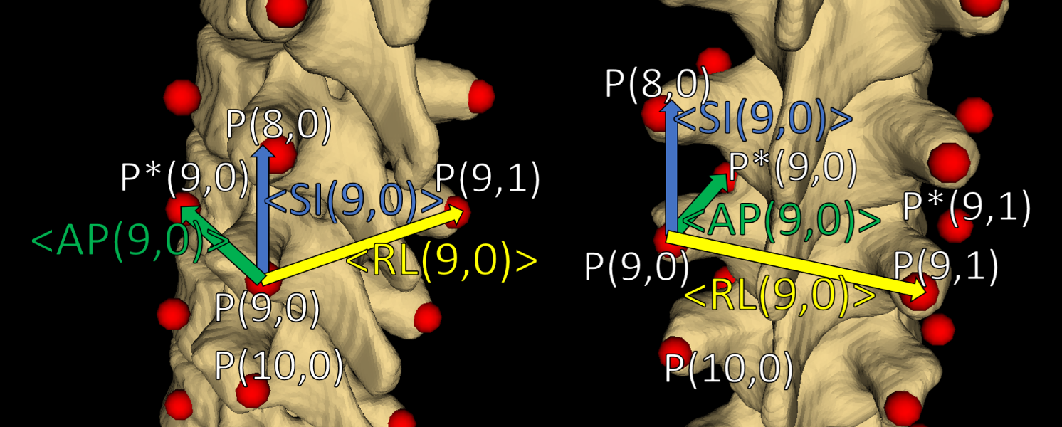

Figure 4: Two views of a piece of the average spine model. Transverse process points, anchor points, and illustrations of the vectors used to locate one anchor point are shown. The points used to calculate vectors are labelled. The superior-inferior vector is the result of an average and therefore does not point directly to P(8,0). Vectors are added for illustration and therefore are not necessarily exact.

# RESULTS

The method was tested on CT data from four pediatric scoliosis patients. The resulting visualizations are shown in Figure 5. Typically, the top and bottom vertebral levels of patients’ ultrasound scans are variable. To account for this, the average spine model is truncated to match the vertebral levels in the patient’s spine.

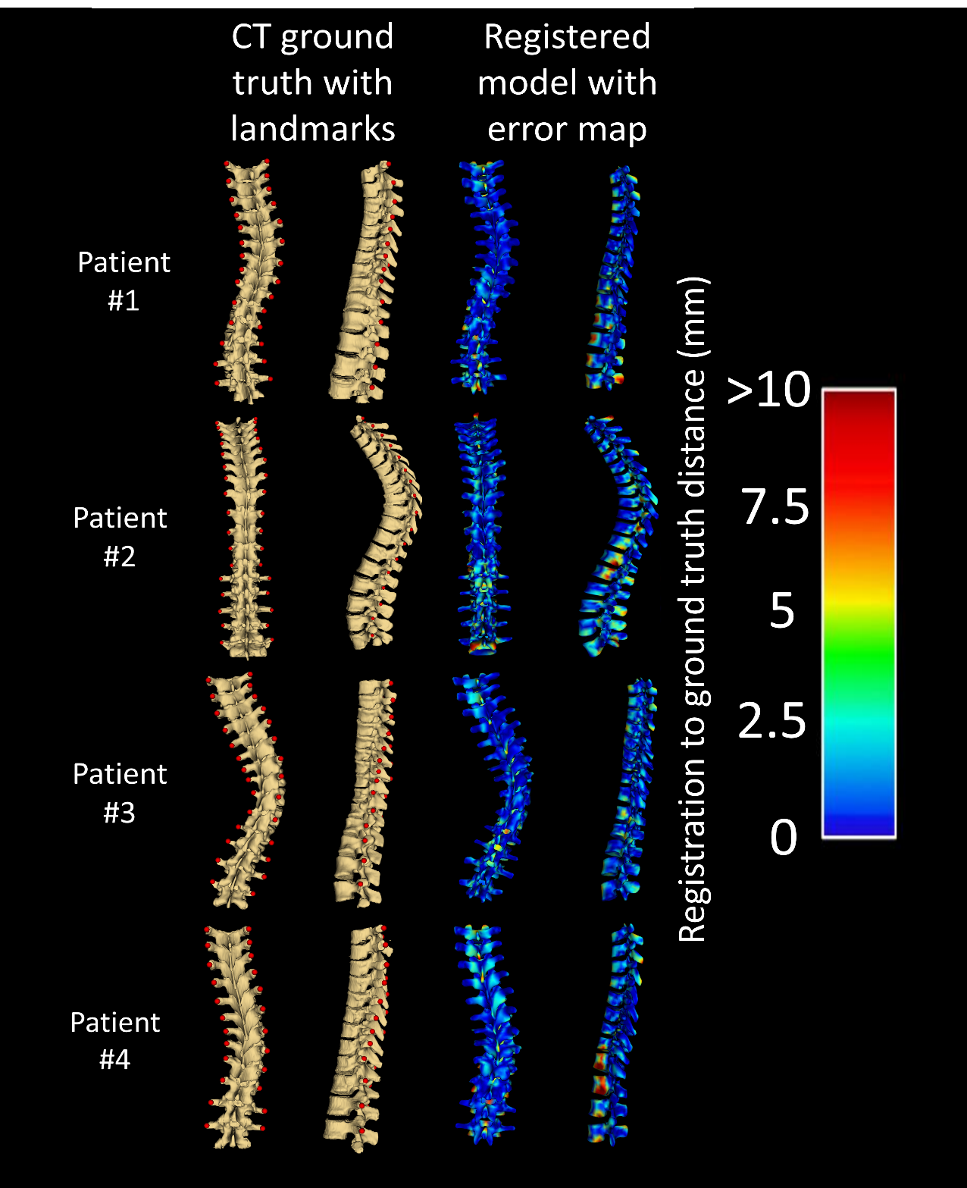  
Figure 5: CT derived ground-truth models with original transverse process points, posterior and left views. Registration based warping applied to average spine model visualization with error map showing absolute distance to ground-truth, posterior and left views.

Quantitative registration evaluation metrics are shown in Table 1. Hausdorff distances were chosen over the Dice similarity coefficient as registration metrics because the Dice similarity coefficient is not suitable for shapes containing thin structures, like the spine.

Table 1: Registration evaluation metrics

|  |  |  |  |
| --- | --- | --- | --- |
|  | | **Registration Metric** | |
| **Avg. Hausdorff Distance (mm)** | **Max. Hausdorff Distance (mm)** |
| **Patient #** | **1** | 2.8 | 20.0 |
| **2** | 2.3 | 24.0 |
| **3** | 2.4 | 17.7 |
| **4** | 2.9 | 18.1 |

# DISCUSSION

Figure 5 demonstrates that the method achieves the intended purpose of producing intuitive 3D visual representations of the scoliotic spine as a potentially useful aid to clinicians. Visual inspection revealed accurate rendering of the scoliotic spine relative to the ground truth CT. Notable misalignments occurred mainly in the anterior anatomy, and at the first and last vertebra, where the registration lacked the extra anchor points. However, these regions are immaterial for scoliosis quantification as an ultrasound scan will be centered about the curvature, and viewed from the posterior direction. The maximum Hausdorff distances may be misleadingly large because of the spinous processes, with no landmarks to constrain their deformation to that seen in the patients.

Patients #2 and #4 are illustrative of one of the factors which made generation of accurate visualizations a challenge. The undeformed models’ vertebral bodies are wider in the anterior-posterior, and right-left directions as illustrated in Figure 6. The ASF shrinks the model’s vertebral bodies in the anterior-posterior direction upon registration, but they are left too wide in the right-left direction. The result is that the vertebral bodies seen just below the midpoints on Patient #2 and #4’s spines in Figure 5, which extend past the patients’ ground truths in the right-left directions. Future implementations seeking to improve the registration of the anterior anatomy will need to adjust the right-left spacing between anchor point pairs to scale the anatomy in this direction as well.

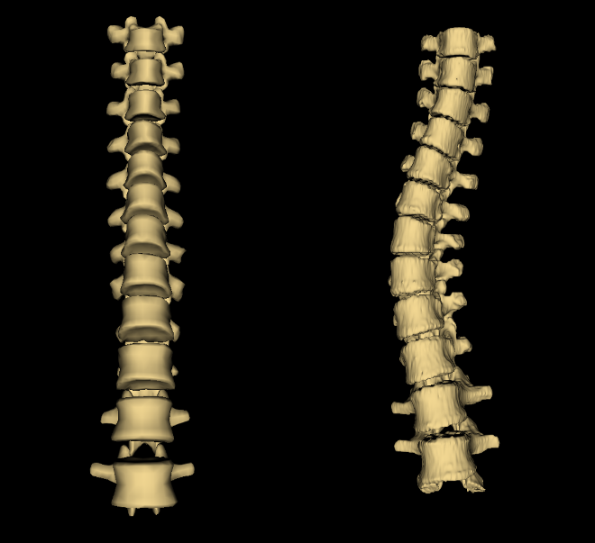

Figure 6: Left – Undeformed average spine model truncated to contain the same vertebrae as Patient #4. Right – CT-derived ground truth for Patient #4. The model’s lower vertebrae become wider than its upper vertebrae, more so than the lower vertebrae of the patient.

We stress that for both diagnostic and therapeutic purposes, the spinal curvature is computed from the transverse process landmarks [2]. The purpose of the work presented in this paper is aiding the physician in the visual perception of the curvature that is virtually impossible to see or feel from the sparse skeletal landmarks alone.

It is of note that this method is not strictly limited to scoliosis visualization with the transverse processes or ultrasound imaging. Scoliosis is a clinically significant and challenging application to test our approach, where the associated deformation constitutes difficult anatomy for model registration from sparse anatomical landmarks. Our method was designed on the basis of the symmetry and relative locations of the ultrasound-accessible landmarks, in this case, the transverse processes. However, other landmarks could be retrieved from any imaging modality and the method adapted to suit their geometric properties.

# CONCLUSIONS

The modified landmark-based registration method presented in this paper is capable of producing three-dimensional visualization of the scoliotic spine using just two ultrasound-accessible landmarks per vertebra as input. Most of the registration’s misalignment occurs anterior and posterior to the vertebral faces, in the vertebral bodies and spinous processes, respectively. This misalignment is the result of being distant from the landmarks used for scoliosis quantification and as input to our method, and as such, is of no clinical significance in the visual assessment of the extent and nature of the scoliosis; it does not affect the visual perception of the spinal curvature.

# ACKNOWLEDGMENTS

This work was supported in part by the Discovery Grants Program of the Natural Sciences and Engineering Research Council of Canada (NSERC) and the Applied Cancer Research Unit program of Cancer Care Ontario with funds provided by the Ontario Ministry of Health and Long-Term Care. Gabor Fichtinger was supported as a Cancer Care Ontario Research Chair in Cancer Imaging. Ben Church was supported by the Canadian Graduate Scholarship program of NSERC.

# REFERENCES

1. Cheung CW, Zhou GQ, Law SY, Mak TM, Lai KL, Zheng YP. “Ultrasound Volume Projection Imaging for Assessment of Scoliosis”. IEEE Trans Med Imaging. 2015 Aug; 34(8):1760-8.
2. Ungi T, King F, Kempston M, Keri Z, Lasso A, Mousavi P, Rudan J, Borschneck DP, Fichtinger G. “Spinal curvature measurement by tracked ultrasound snapshots”. Ultrasound in Medicine and Biology. 2014 Feb; 40(2):447-54.
3. Wang Q, Li M, Lou EHM, Wong MS. “Reliability and Validity Study of Clinical Ultrasound Imaging on Lateral Curvature of Adolescent Idiopathic Scoliosis”. PLOS ONE. 2015 Aug; 10(8):1-16.
4. Gill S, Abolmaesumi P, Fichtinger G, Boisvert J, Pichora D, Borshneck D, Mousavi P. “Biometrically constrained groupwise ultrasound to CT registration of the lumbar spine”. Medical Image Analysis. 2012; 16, 662-674.
5. Rasoulian A, Abolmaesumi P. “Feature-based multimodal registration of CT and ultrasound images of lumbar spine”. Medical Physics. 2012 June; 39(6): 3154-3166.
6. Hacihaliloglu I, Rasoulian A, Rohling R, Abolmaesumi P. “Local Phase Tensor Features for 3-D Ultrasound to Statistical Shape+Pose Spine Model Registration”. IEEE Transactions on Medical Imaging. 2014 Nov; 33(11):2161-2179.
7. Bookstein F, “Principal Warps: Thin-Plate Splines and the Decomposition of Deformations”. IEEE Transactions on Pattern Analysis and Machine Intelligence. 1989 June; 11, 567-585.